Test plan on The Tutorial Ninja Website

**Introduction**

The document aims to give an overview of the testing approach, strategies, and scope for the [Qafox.com](https://tutorialsninja.com/demo/). This document includes details like the scope of the project, objectives, test schedule and resource allocations, test deliverables, and reports.

# **Objectives**

## Primary Objective

* Validate the functionality, usability and performance of the Qafox.com.

## Objectives

* Ensure that the app meets the specified requirements and user expectations.
* Identify and mitigate potential risks to ensure a smooth user experience.

# **Scope**

This test plan only covers functional testing, performance testing and compatibility testing of the Qafox.com across different browsers.

# **Testing Features**

* User registration
* Login
* Password

# **Testing Approach**

## **Testing Types**

* **Functional Testing**: Functional testing is a type of software testing that verifies the functionality of an application against its specified requirements. It focuses on testing each feature or function of the software to ensure it behaves as expected, including user interactions, data processing, and integration with other systems, without considering internal code structure.
* **Performance Testing**: Performance testing is a type of software testing that evaluates how a system performs under various conditions, such as load, stress, and volume. It aims to identify performance bottlenecks, ensure stability, and measure response times, throughput, and resource usage to ensure the system meets required speed and scalability standards.
* **Usability Testing**: Usability testing is a technique used to evaluate how easy and effective a product is for users. It involves observing real users as they interact with the product to identify any issues or areas for improvement, ensuring the product meets user needs and expectations.

## **Testing Methodology**

* **Black-box testing**: Black-box testing is a software testing method that examines the functionality of an application without knowing its internal code or structure. Testers focus on input and output, verifying that the software behaves as expected, ensuring it meets user requirements and specifications. It's useful for identifying issues like usability and performance defects.
* **White box testing**: White box testing is a software testing method where the internal structure, design, and implementation of the application are known to the tester. The tester uses this knowledge to design test cases that thoroughly examine the code, logic, and data flow, ensuring all paths and conditions are tested for correctness.
* **Regression testing**: Regression testing is a software testing practice that ensures that recent code changes haven't adversely affected existing features. It involves re-running previously passed test cases to confirm that new code modifications don’t introduce new bugs or regressions in the software's functionality. This helps maintain software quality.
* **User Acceptance Testing**: User Acceptance Testing (UAT) is the final phase of software testing where actual users test the software in a real-world environment to ensure it meets their requirements and works as expected. UAT focuses on validating the functionality, usability, and overall performance of the software before it is released.

## **Operating System**

* Windows 11 or above.
* Browser: Chrome, Microsoft Edge, Firefox
* Testing Tools: Selenium

# **Automation Requirements**

## **Requirements**

1. Main folder having .env file, Login.py, Register.py, Chrome driver directory.
2. Python modules os, time, pathlib, selenium.

## Selenium Module installation

1. Go to the terminal/ Command Prompt
2. Write: pip install selenium
3. To check the module list or selenium is

installed Write: pip list.

### Chrome Driver:

1. Go to the link: <https://googlechromelabs.github.io/chrome-for-testing/#stable>
2. Choose Stable and Binary as Chrome Driver: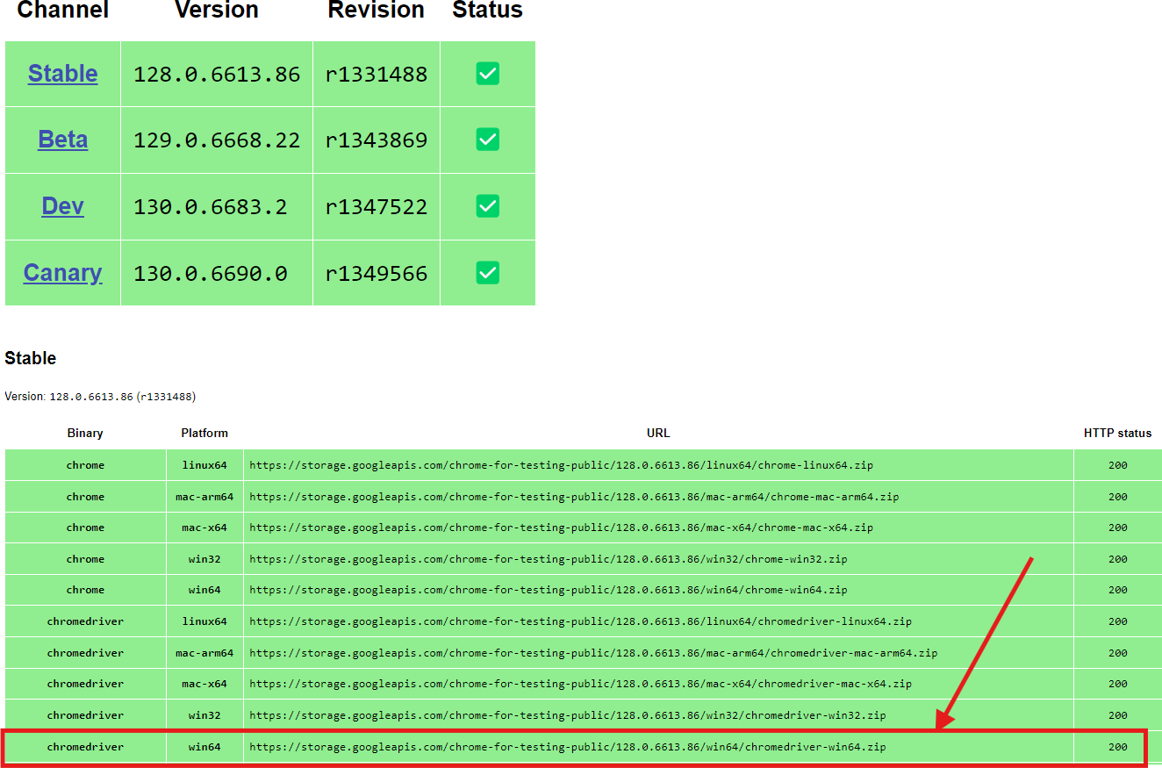
3. Extract all and save the chrome driver in current Working directory.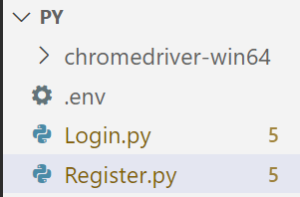

### Env file(.env):

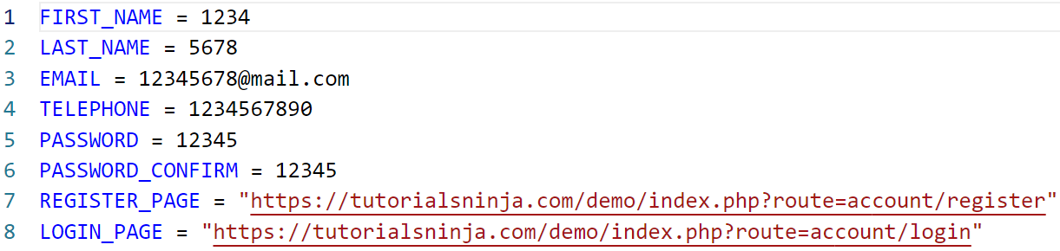

### Login file:

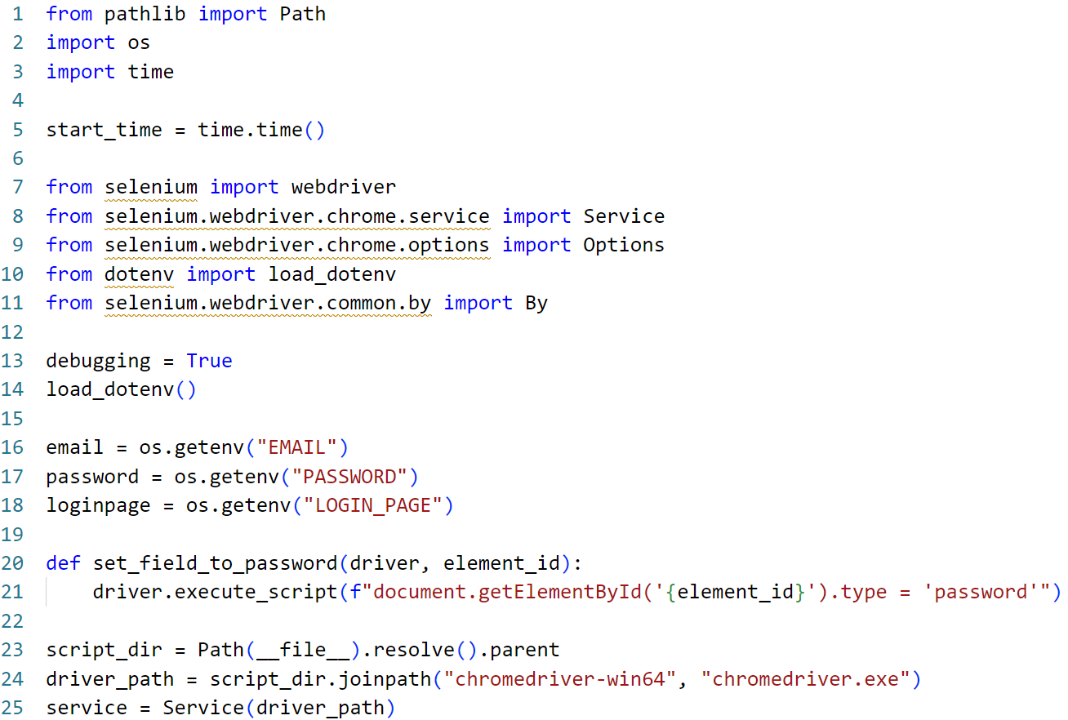

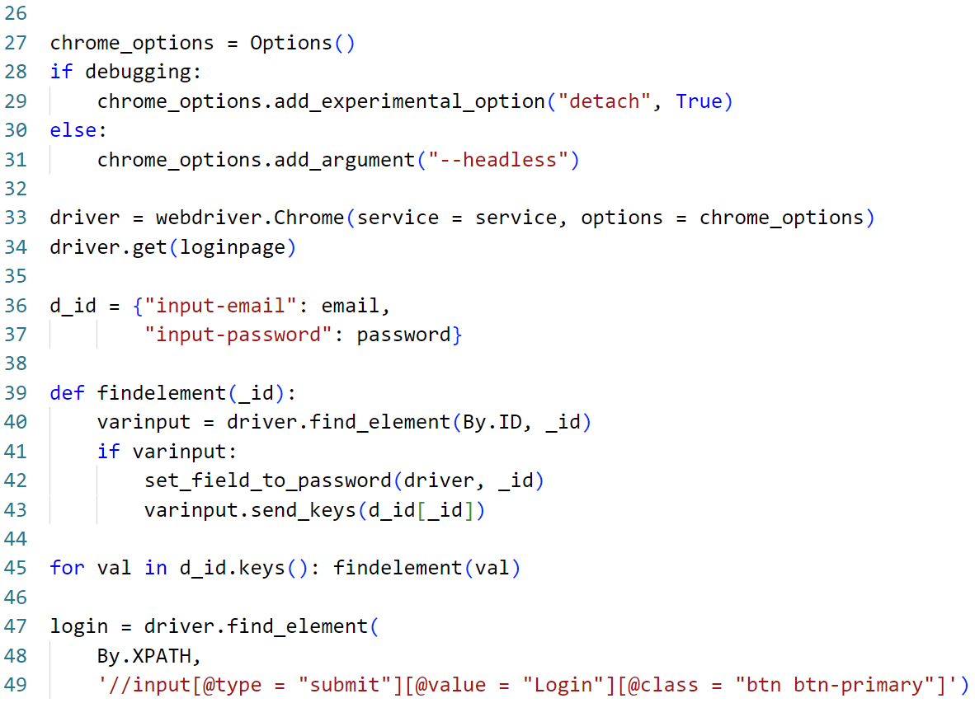

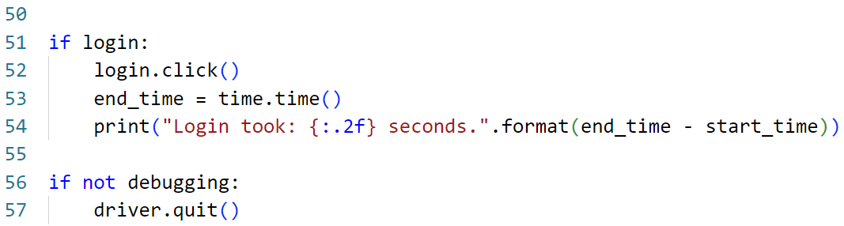

### Register File:

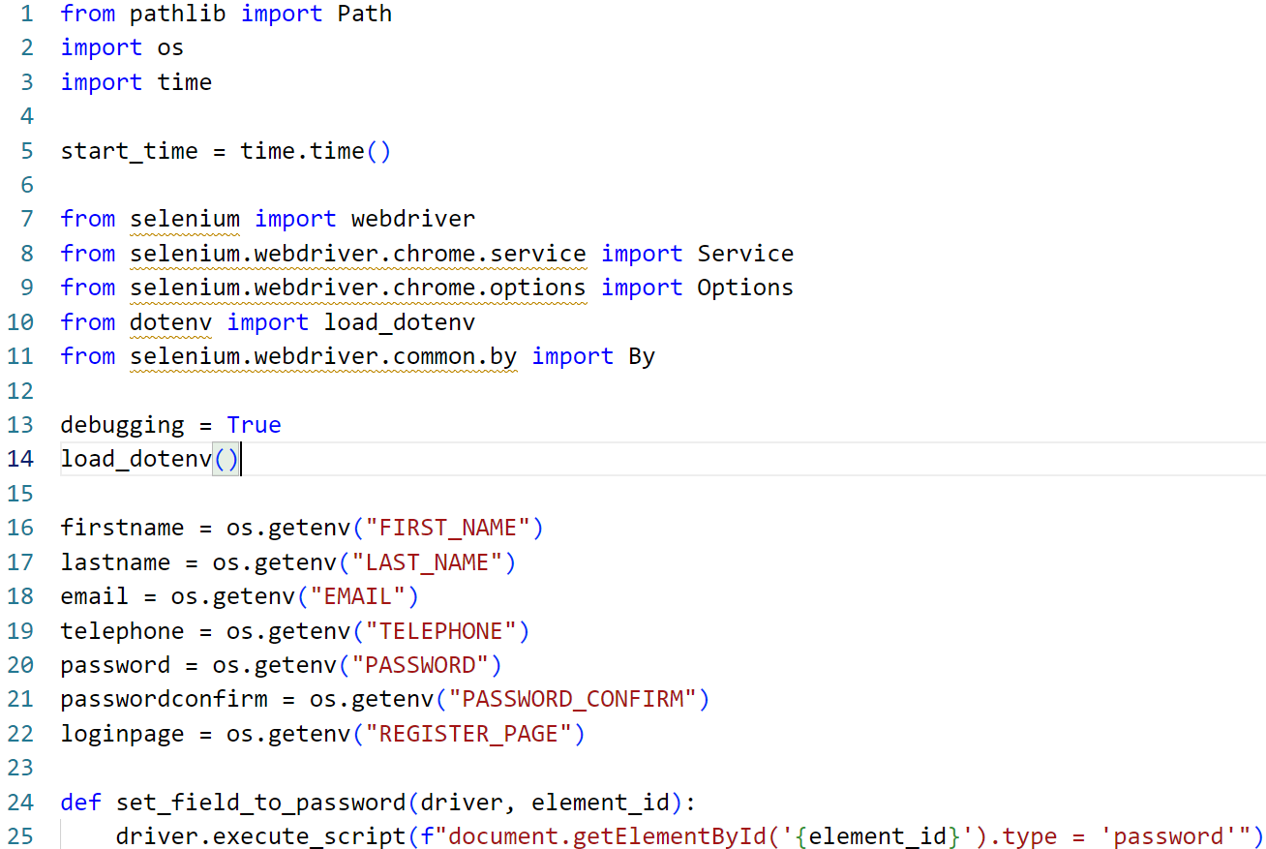

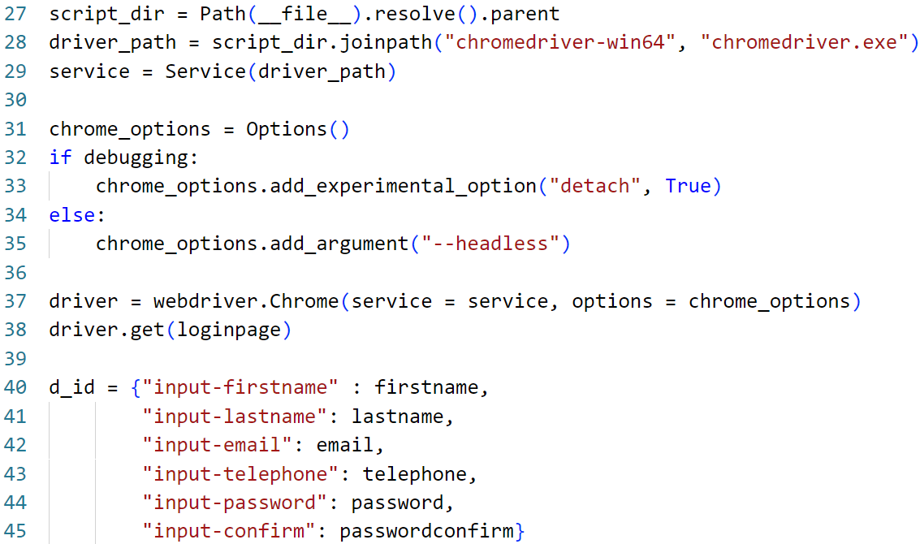

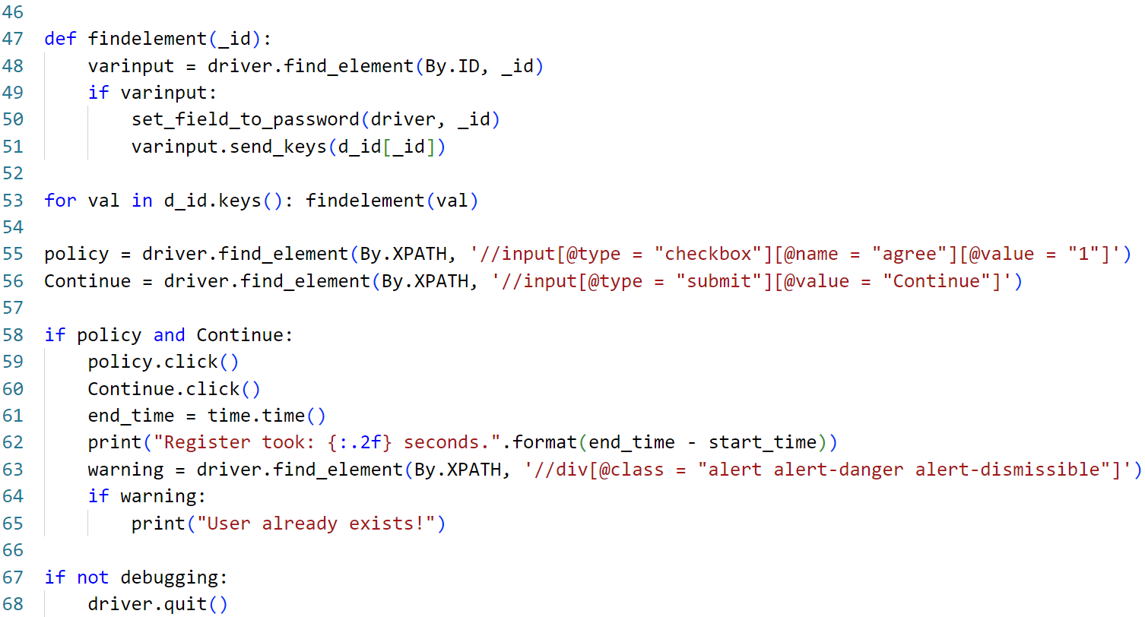

# **Entry and Exit Criteria**

The below are the entry and exit criteria for every phase of the Software Testing Life Cycle:

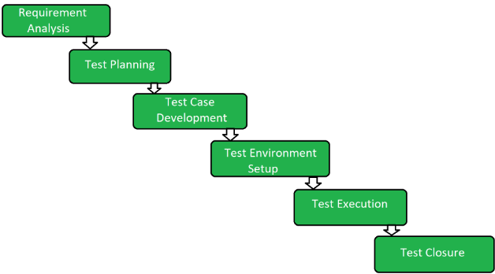

## **1.** **Requirement Analysis**

### **Entry Criteria**

Once the testing team receives the Requirements documents and user documents of the project. Includes what functions need to be tested and how the software should behave.

### **Exit Criteria**

The testing team thoroughly explore and understand each requirement listed in the documents. Any doubts and uncertainty regarding the requirement should be addressed and clarified to ensure that the testing team has a clear understanding of what need to be tested and how it should behave.

## **2.** **Test Planning**

### **Entry Criteria**

The planning phase begins once the project plan is approved and detailed requirements are available.

### **Exit Criteria**

The phase concludes with the approval of the test plan document by the Client.

## **3.** **Test Designing**

### **Entry Criteria**

The design phase starts after the test plan is approved. It requires detailed functional and non-functional requirements and access to design tools and environments.

### **Exit Criteria**

The phase ends when all Test Cases and Test Scenarios are reviewed and approved.

## **4.** **Test Execution Phase**

### **Entry Criteria**

Execution starts when Test Cases and Test Scenarios are ready, and the test environment is set up. Test data must be prepared and validated, and the test team must be trained.

### **Exit Criteria**

Test Case Reports, Defect Reports are ready.

## **5.** **Test Closure**

### **Entry Criteria**

Test Case Reports, Defect Reports are ready.

### **Exit Criteria**

## It concludes with the preparation and review of the test summary reports.

# **Tools**

The following are the list of Tools we will be using in this Project:

* Miro- map Tool
* Jira - Project management tool
* Zephyr- Test Management
* Selenium - Web Automation

# **Risks and Mitigation Plans**

The following are the list of risks possible and the ways to mitigate them

| **Risk** | **Mitigation plans** |
| --- | --- |
| **Lack of Expert Automation Testers** | Backup Resource Planning |
| **No detailed Requirements are available** | Subject matter experts available for a deep understanding of functionalities |

# **Approvals**

Masai will send different types of documents for Client Approval like below:

1. Test Plan
2. Test Scenarios
3. Reports

Testing will only continue to the next steps once these approvals are done.